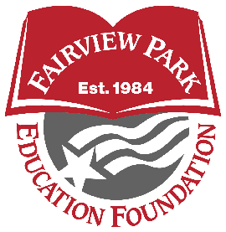
Fairview Park Education Foundation
_________________________________________________________________________________________________
P. O. Box 26378 ● Fairview Park, Ohio 44126 ● (440) 343-5389

Dear Staff,

The Fairview Park Education Foundation was formed in our community to provide additional financial support for our schools. The purpose of the Foundation is to provide funds not available from public monies for the enrichment of school curriculum, the enhancement of instruction, and the implementation of other appropriate activities to achieve specific educational goals.

Since 1984, the Foundation has awarded more than 500 grants to staff from pre-kindergarten through twelfth grade. The grants are funded through individual donations and proceeds from various fundraisers. We hope many of you will apply for a grant.

Our final selections, as always, will be based on the funds available to us, the number of petitioning grants, and the amount of the dollars requested, which must meet the stated goals of the Foundation. Grants, generally, may not be given on consecutive and/or subsequent years unless such funds are available based on the number and dollars requested. If a grant is not approved in one year, it does not preclude anyone from requesting the grant in subsequent years. We ask that when the grants are awarded, they should be used within one year of the approval letter date. We also ask that you provide a report with pictures after the completion of your grant. Remember, the more students at the various levels who can benefit from the projects – the better.

Directions
Download the grant application above. Answer all questions thoroughly so we have a full understanding of your grant request. Additional information regarding the project or program may be attached to your application.

Proposal Submission
Proposals must be submitted via email by Friday, November 1, 2024, to:

Jean Scothon, Grants Committee Chairman at jscothon4@gmail.com

Please do not send applications to the board office. Only email them to Jean Scothon.

2024 Board of Trustees
______________________________________________________________________________________
Denise Devine President
Clare Kundmueller Vice President
Richard Cause Treasurer
Kristin Broadbent Recording Secretary

Patty Beard Trustee Chuck Kullik Trustee
Tom Davis Trustee Christine McElwee Trustee
Jessica Eidson Trustee Jean Scothon Trustee
Jan Hoeffler Trustee Marcy Starks Trustee
Tim Jackson Trustee Keith Ahearn Superintendent
Tom Kairis Hall of Fame Trustee John Straka Board of Education Representative

